ABSTRACT
University students are increasingly exposed to a variety of academic, lifestyle, and psychological stressors that may influence their mental well-being and academic success. This case study investigates the relationship between key factors—such as age, academic pressure, work pressure, study satisfaction, financial stress, dietary habits, sleep duration, and family history of mental illness—and their potential impact on suicidal thoughts and CGPA performance among students.
Using a data-driven approach, the study explores how each variable contributes to psychological stress and academic outcomes, with particular focus on the presence of suicidal ideation. The findings suggest that academic pressure, poor sleep duration, financial stress, and a family history of mental illness are strongly correlated with increased mental health risks, while higher study satisfaction and healthier lifestyle habits are associated with better academic performance and lower psychological distress.
The study aims to provide insights into the multifaceted causes of mental health struggles in academic settings, offering valuable information for mental health professionals, educators, and policymakers to improve student support systems.
\

INTRODUCTION
University life is a period marked by significant academic challenges, lifestyle adjustments, and psychological transformations. During this transitional phase, students often face multiple stressors such as academic pressure, financial burdens, sleep disturbances, and changes in dietary habits. These factors can significantly influence their mental well-being and academic performance.
In recent years, there has been an alarming increase in mental health concerns among students, particularly suicidal ideation, often stemming from a complex mix of personal, environmental, and academic variables. This case study seeks to analyze the relationship between various socio-demographic, lifestyle, academic, and psychological variables—including age, study satisfaction, sleep duration, CGPA, work pressure, and family history of mental illness—on the presence of suicidal thoughts.
This study aims to investigate how a combination of academic pressures, lifestyle habits, and psychological factors relate to suicidal thoughts among university students. By identifying the most influential variables, the goal is to provide insights that can support the development of targeted mental health interventions and improve student well-being.

OBJECTIVES:
(1) To investigate the relationship between academic pressure and study satisfaction with mental health indicators such as suicidal thoughts among university students. (2) To analyze the influence of lifestyle factors, including dietary habits and sleep duration, on student’s psychological well-being. (3) To assess the impact of work pressure and financial stress on the prevalence of suicidal ideation in the student population. (4) To examine the role of family history of mental illness as a potential risk factor for suicidal thoughts. (5) To evaluate the correlation between academic performance (CGPA) and mental health status, considering the combined effects of academic and lifestyle stressors. (6) To provide recommendations for mental health support interventions tailored to students experiencing multiple stressors.

METHODOLOGY
The analysis follows a structured approach similar to traditional OLS-based studies, adapted for logistic regression using Python libraries such as pandas, scikit-learn, seaborn, and matplotlib.
(1) Data Collection and Preparation: The dataset includes variables like Age, CGPA, Academic Pressure, Sleep Duration, and others related to lifestyle and mental health. Data cleaning involved handling missing values, encoding categorical variables, and normalizing numerical features using pandas and scikit-learn.
(2) Model Specification and Representation: A logistic regression model was chosen due to the binary nature of the target variable—suicidal thoughts. Predictor variables include academic, lifestyle, and psychological factors.
(3) Coefficient Estimation Using Logistic Regression: The model was trained using scikit-learn’s LogisticRegression, and coefficients were extracted to interpret the influence of each independent variable.
(4). Prediction of Values: The dataset was split into training and testing subsets. Predictions were made

on the test set to evaluate the model’s generalization ability.
(5) Interpretation and Visualization of Results: Model performance was assessed using accuracy, precision, recall, and F1-score. A confusion matrix was visualized using seaborn and matplotlib to understand classification effectiveness. The coefficients helped identify key factors influencing suicidal thoughts.

Data
This case study used a Kaggle dataset that focused on the mental health of a student and it contains variables such as Study Satisfaction, Financial Stress, Dietary Habits, Age, Sleep Duration, suicidal thoughts, Family History of Mental Illness, CGPA, Academic Pressure. Which is a good variables for modeling.
Data Preprocessing
Figure 1: Code
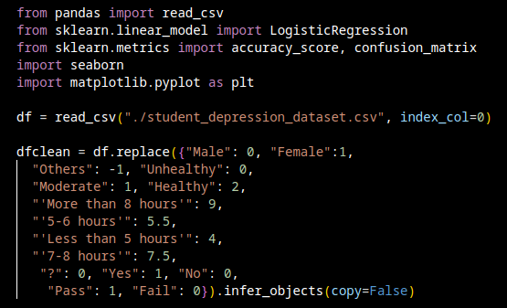
this code is used import required modules and to convert non-integer (categorical) variables into integers is called encoding. This is a critical step before feeding the data into most machine learning models, which typically require numerical inputs.
Figure 2: code that filters out useless variables and only include useful variables.
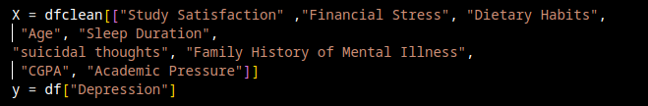
removing irrelevant or redundant variables from the original dataset to improve model performance and interpretability. The goal is to select features that are most predictive of your target (Depression), reducing noise and overfitting.

Data Modeling
Figure: simple modeling code
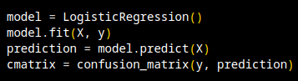
This code trains a logistic regression model on features X and target y, makes predictions on the same data, and evaluates the results using a confusion matrix.

Accuracy
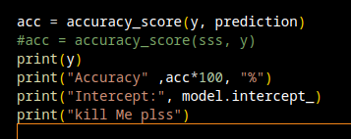
Figure: code to display how accurate the model performance is.
This code is used to display the model accuracy and Intercept to show how the model is performing. With the Accuracy of 84.28%, and Intercept of -1.27157241, it shows that the model is performing quite well.
Visualization
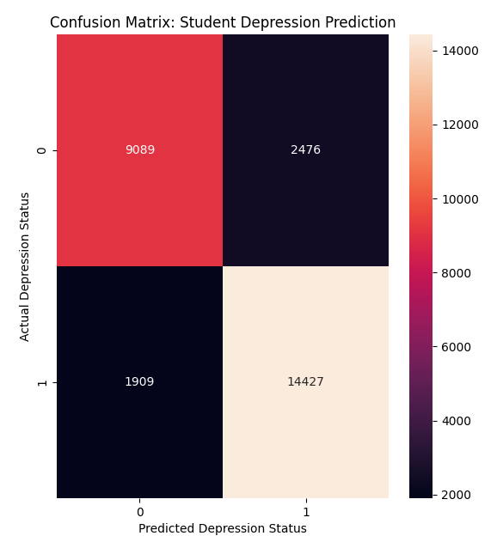
Table 1: Confusion Matrix
Confusion Matrix shows the Actual vs. Predicted values for a classification model, where the x-axis represents the Predicted Depression Status and the y-axis represents the Actual Depression Status. It shows that there is 9098 True Negatives, 14427 True Positives, 2476 False Positive, 1909 False Negatives With Accuracy of 84.28 %. It helps evaluate the performance of the model by comparing how many predictions were correct or incorrect. This matrix helps in understanding errors like false positives (predicting depression when there isn’t) and false negatives (missing actual depression), which is important in sensitive fields like mental
ealth prediction.

Table 2: Students Degree Bar Graph.
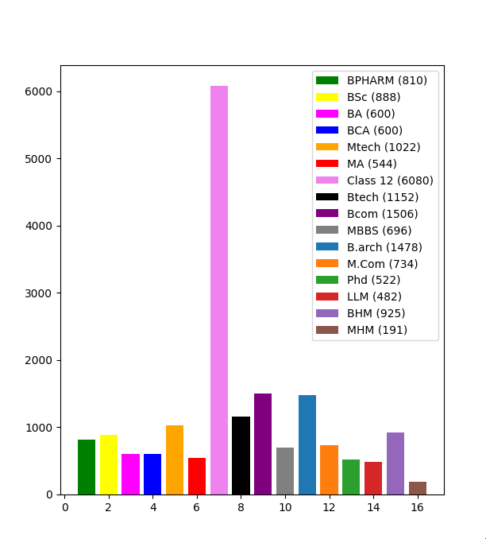
This bar chart displays the number of students from different educational backgrounds. Each bar represents a specific course or level of education, and the height of the bar indicates how many students belong to that category.
"Class 12" has the tallest bar, with 6080 students, meaning it's the most represented group.
Other large groups include:
Bcom with 1506 students
B.arch with 1478 students
Btech with 1152 students

Smaller groups include:
MHM: 191 students
LLM: 482 students
PhD: 522 students
Each bar is color-coded and labeled for clarity, with the exact number of students shown in parentheses in the legend. The x-axis shows the categories, while the y-axis shows the student count.

TABLE 3: Gender Bar graph
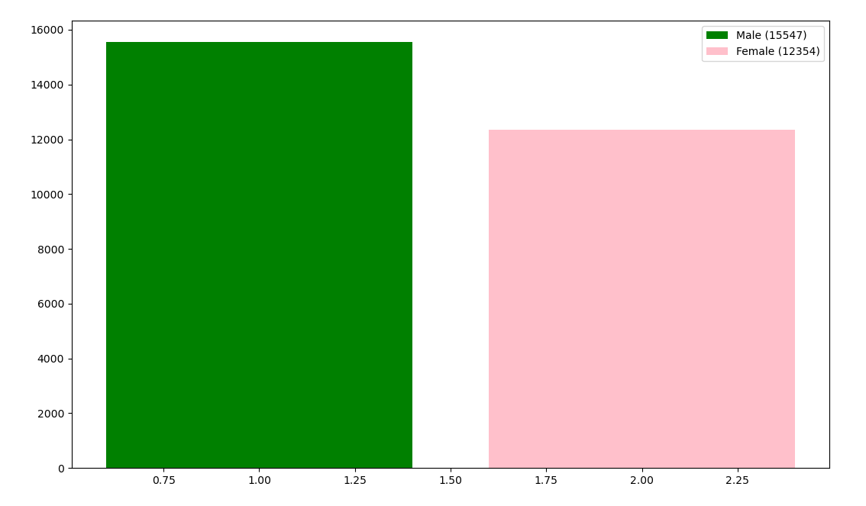
This bar chart was created using Matplotlib to visualize the gender distribution in a dataset. It shows that there are 15,547 males and 12,354 females, with the male bar colored green and the female bar in pink. The chart includes a legend that labels each gender along with their respective counts, making it easy to compare the values at a glance.

CONCLUSION
This study explored the impact of academic, lifestyle, and psychological factors on suicidal thoughts among students using logistic regression. By analyzing variables such as academic pressure, financial stress, sleep duration, and family history of mental illness, we identified key contributors to mental health risks.
The model revealed that academic and financial pressures, along with family mental health history, were significant predictors of suicidal ideation. Conversely, healthy sleep patterns and study satisfaction showed protective effects.
These findings highlight the urgent need for mental health support systems within academic institutions. Targeted interventions can be designed based on these predictors to help students cope with stress and improve their well-being.
REFERENCES
Student depression dataset.
https://www.kaggle.com/code/saifeldeenmohammedm/student-depression-dataset
Case Study Source Codes.
https://github.com/AlieeLinux/case-study

